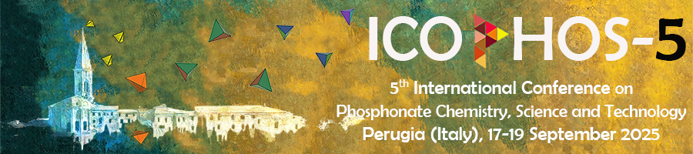

Submission of contribution to ICOPHOS-5

Author name
Affiliation
Phone number
E-mail:

Please indicate the preferred mode of presentation:

[ ] Oral Presentation
[ ] Poster Presentation
[ ] Either

Please fill this form, prepare your abstract following the template below and then submit your contribution by e-mail to: icophos5@gmail.com
before May 15, 2025

Title

First Author¹, Second Author², Corresponding Author¹* (underline the presenting author, put an asterix after the name of the corresponding author; use initials for first and middle names)
¹ Institution. Department. Address. Country; ² Institution. Department. Address. Country…
(*) corresponding.author@email.com

This is a set of instructions for preparing your paper. These instructions have been formatted to look like your paper. If you have any problems with formatting, please contact the ICOPHOS-5 Secretariat at icophos5@gmail.com.
It is mandatory to limit your abstract to 1 A4 page (210 x 297 mm), including Tables, Figures and References.
The paper in electronic format can be sent before May 15, 2025 as an e-mail attachment in WORD format to icophos5@gmail.com

The one-page abstract must be in English (11 point, Arial font, single line spacing) and will have left and right, top and bottom margins of 2 cm. All pages must be in portrait orientation. Use only single column format as shown here. Full justification should be used.
On the top of the page, place the title of the paper (bold, 12-point, Arial font, aligned centre). Leave one blank lines of 11-point font, and then list authors (11-point Arial font, aligned centre). Each author’s current affiliation should include full address and email if applicable, (11-point Arial font, justified).

References

[1] F.M. Last name, Abbreviated-journal-name volume (year) page-numbers (11-point Arial font)

